Darling Street Health Centre
1/449 Darling Street
Balmain 2041
9555 8806
Natural Wisdom
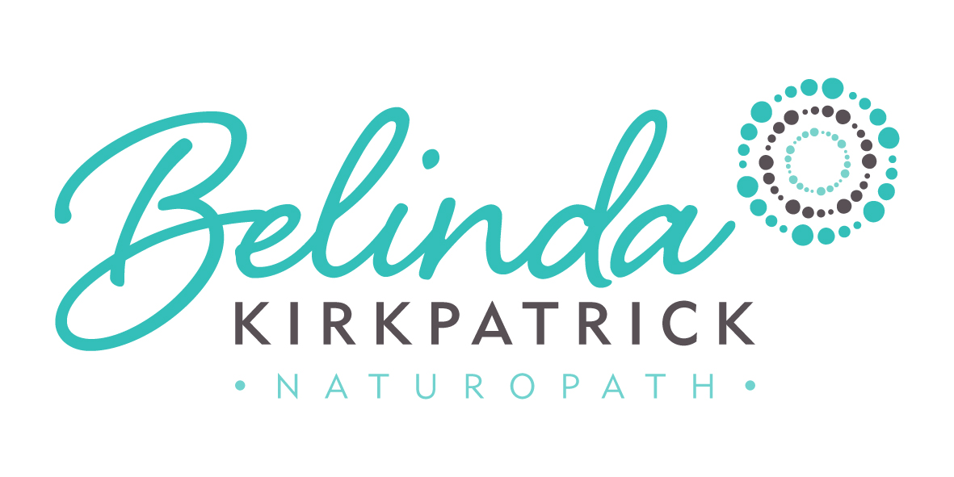
220a Glenmore Rd
Paddington 2021
0400 551 622

www.belindakirkpatrick.com.au
belinda@belindakirkpatrick.com.au

Chia Puddings

Chia seeds are truly one of nature’s super super superfoods! They are high in protein, fibre, calcium, omega 3’s, vitamin C
Chia seeds are amazing for increasing satiety (and so can help with weight loss ), balance blood sugar levels, improve sluggish bowels, improve energy levels and provide a great school or work lunch box snack, quick breakfast or yummy dessert.
Chia seed puddings are incredible forgiving and can be made by ANYONE! If you find they are too runny, just add more chia seeds and pop back in the fridge for ten minutes, if they are too hard, just add more liquid and in ten or so minutes they will be the right consistency.
The rule with chia puddings is to add around 2-3 tablespoons of chia seeds to 1 cup of liquid and then leave in the fridge for an hour (or overnight) to set. I tend to make them for several days in advance. They look super cute for a snack when set in a little baby-food type jar. You can vary the consistency to suit yourself – I tend to aim for a mousse-like consistency.
Liquids you may choose to add may include: milk, almond milk, coconut milk (diluted or staright up) or coconut water. You can add fresh, frozen or pureed fruit. I always add cinnamon and vanilla paste for extra flavor. When I have time, I blend up a smoothie and use that for the liquid base.
The possibilities are endless but easy favourites include:
- Coconut milk, vanilla paste, cinnamon and chia seeds stirred together
- Blended banana, mango, vanilla, coconut milk – add chia seeds after blending
- Frozen raspberries, banana and milk in the blender – add chia seeds after
- Blended banana, mango and pineapple juice – add chia seeds after
- Frozen raspberries with coconut milk, raw cacao blended – add shredded coconut and chia seeds after

